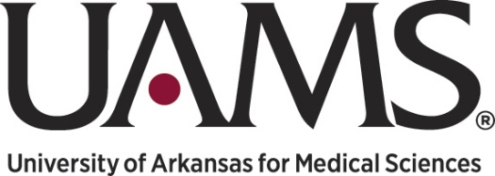
presents

HEALERS
(The Healthcare Education Active Learning Experience for Regional Scholars)

Dear Student:

We are pleased to announce that the 2022 HEALERS program will be held during the dates of Monday, June 13 through Friday, June 24, 2022; attendance will be mandatory each day, Monday through Friday, from 8:30am to 3:30pm.

The HEALERS Program is open to students residing in Pulaski County, entering their junior or senior year of high school in the fall of 2022. The application deadline is Thursday, March 31, 2022; there are no exceptions. If selected as a finalist, you will be required to participate in an interview with the selection committee.

Candidates selected for interviews will receive an email no later than April 8, 2022, requesting your preference of interview times; interviews will be held April 11-15 from 4-6pm, in 15 minute increments. Notification of acceptance to the program will be made no later than Friday, April 22, 2022.

Please complete the application; all answers provided on the student application portion must be written by you, in your own words.

After completing the application, please download the HEALERS Recommendation Form. This form must be completed by a teacher, counselor or community leader who can best evaluate your skills as a student and critical thinker. A copy of your high school transcript must also be included with your application, emailed to mbthacker@uams.edu.

Applications will be accepted once they are FULLY completed, including all of the aforementioned items. You may contact me at mbthacker@uams.edu to verify whether your application has been received.

