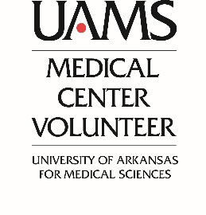

01/01/2020

Ms. Smith
123 Main St.
Pleasantville, AR 12345

In-Kind Donation
Tax Receipt
UAMS Medical Center Auxiliary
Tax ID# 52-0219633

Date | Donation | Condition | Value (to be submitted by donor)

No services or goods were provided in exchange for or in connection with this donation.
Please retain this document as a written proof of your donation for your tax records.

____________________________________
Jennifer Huie, Director- Office of Volunteer Engagement and Auxiliary
University of Arkansas Medical Center
4301 W. Markham St Slot#527
Little Rock, AR 72205
501-686-5656

